

**University Institute of Engineering**

**Lab File**

**Subject Name: COMPUTER PROGRAMMING AND UTILIZATION LAB**

**Subject Code: UCP-145**

**Batch: 2017 -2021**

**Submitted By: Submitted To:**

**Name: Rishav Shankar Ms Prathiba Vasu**

**UID: 17BCS4169**

**Computer Science and Engineering IBM, Chandigarh University, Gharuan**

|  |  |  |  |  |  |  |  |  |  |
| --- | --- | --- | --- | --- | --- | --- | --- | --- | --- |
| **CPU LAB INDEX** | | | | | | | | | |
| **Student Name: Rishav Shahi** | | | | | **UID: 17BCS4169** | | | | |
| **Subject Name: Computer Programming and Utilization** | | | | | **Subject Code: UCP-145** | | | | |
| **Branch & Section: CSE IBM CC2** | | | | | **Group: 2** | | | | |
| **S. No.** | **Name of Experiment** | **Page No.** | **Date** | **Marks** | | | | | **Teacher’s Signature** |
| **LW** | | **FW** | **VW** | **TM** |
| **12** | | **10** | **8** | **30** |
|  |  |  |  |  | |  |  |  |  |
|  |  |  |  |  | |  |  |  |  |
|  |  |  |  |  | |  |  |  |  |
|  |  |  |  |  | |  |  |  |  |
|  |  |  |  |  | |  |  |  |  |
|  |  |  |  |  | |  |  |  |  |
|  |  |  |  |  | |  |  |  |  |
|  |  |  |  |  | |  |  |  |  |
|  |  |  |  |  | |  |  |  |  |
|  |  |  |  |  | |  |  |  |  |
|  |  |  |  |  | |  |  |  |  |
|  |  |  |  |  | |  |  |  |  |
|  |  |  |  |  | |  |  |  |  |
|  |  |  |  |  | |  |  |  |  |
|  |  |  |  |  | |  |  |  |  |
|  |  |  |  |  | |  |  |  |  |
| **S. No.** | **Name of Experiment** | **Page No.** | **Date** | **Marks** | | | | | **Teacher’s Signature** |
| **LW** | | **FW** | **VW** | **TM** |
| **12** | | **10** | **8** | **30** |
|  |  |  |  |  | |  |  |  |  |
|  |  |  |  |  | |  |  |  |  |
|  |  |  |  |  | |  |  |  |  |
|  |  |  |  |  | |  |  |  |  |
|  |  |  |  |  | |  |  |  |  |
|  |  |  |  |  | |  |  |  |  |
|  |  |  |  |  | |  |  |  |  |
|  |  |  |  |  | |  |  |  |  |
|  |  |  |  |  | |  |  |  |  |
|  |  |  |  |  | |  |  |  |  |
|  |  |  |  |  | |  |  |  |  |
|  |  |  |  |  | |  |  |  |  |
|  |  |  |  |  | |  |  |  |  |
|  |  |  |  |  | |  |  |  |  |
|  |  |  |  |  | |  |  |  |  |
|  |  |  |  |  | |  |  |  |  |
|  |  |  |  |  | |  |  |  |  |
|  |  |  |  |  | |  |  |  |  |
|  |  |  |  |  | |  |  |  |  |
|  |  |  |  |  | |  |  |  |  |
|  |  |  |  |  | |  |  |  |  |
|  |  |  |  |  | |  |  |  |  |
|  |  |  |  |  | |  |  |  |  |

**EXPERIMENT 1.1:**

**Aim:** Write a program which finds the roots of a quadratic equation. Get values of multipliers a, b and c from user input.

**Program:**

*#include<stdio.h>*

*#include<math.h>*

*void main()*

*{ float a,b,c,p,q,d;*

*printf("Quadratic equation is ax^2 + bx + c=0\n");*

*printf("a is coefficient of x^2 and b is coefficient of x and c is constant\n");*

*printf("\na=");*

*scanf("%f",&a);*

*printf("\nb=");*

*scanf("%f",&b);*

*printf("\nc=");*

*scanf("%f",&c);*

*p=((+sqrt(b*b-4*a*c)-b)/2*a);*

*q=((-sqrt(b*b-4*a*c)-b)/2*a);*

*d=(b*b-4*a*c);*

*if(d>0)*

*{ if(d=0)*

*printf("Roots are equal and they are %f and %d",p,q);*

*else*

*printf("%f and %f are the root of the quadratic equation",p,q);*

*}*

*else*

*printf("Roots are Imaginary");*

*}*

**Input and Output:**

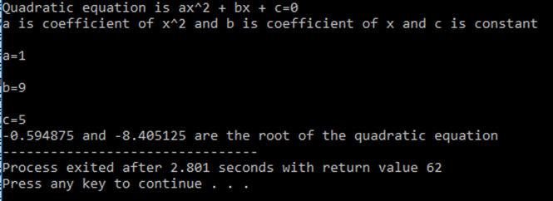

**EXPERIMENT- 1.2**

**Aim:** Write a program to find cos, sin and tan of a given angle.

**Program:**

*#include<stdio.h>*

*#include<math.h>*

*void main()*

*{*

*float a,b,c,pi=3.14,x;*

*printf("Enter value of theta angle\n");*

*scanf("%f",&x);*

*a=sin(x*pi/180);*

*b=cos(x*pi/180);*

*c=tan(x*pi/180);*

*printf("sin of %f is %f\n",x,a);*

*printf("cos of %f is %f\n",x,b);*

*printf("tan of %f is %f\n",x,c);*

*}*

**Input and Output:**

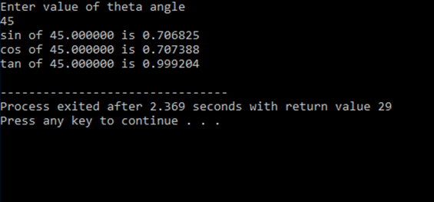

**EXPERIMENT 2.1:**

**Aim:** Write a program to get an integer number (4 digit) as an input and display all digits of that number separate on each line with its individual weightage. For example, if input is 8921, the display should be:

Last digit = 1 having weightage = 1

Next digit = 2 having weightage = 20

Next digit = 9 having weightage = 900

Next digit = 8 having weightage = 8000

**Program:**

*#include<stdio.h>*

*void main()*

*{*

*int a,b,c,d,x,e,f,g,h,i,j,k;*

*printf("Enter a 4 digit number\n");*

*scanf("%d",&x);*

*a=x/1000;*

*b=x%1000;*

*c=x%100;*

*d=x%10;*

*e=c/10;*

*f=b/100;*

*g=j*10;*

*h=f*100;*

*i=a*1000;*

*j=c/10;*

*k=j*10;*

*printf("\nLast digit=%d \tWeightage=%d",d,d);*

*printf("\nThird digit=%d \tWeightage=%d",e,k);*

*printf("\nSecond digit=%d \tWeightage=%d",f,h);*

*printf("\nFourth digit=%d \tWeightage=%d",a,i);*

*}*

**Input and Output:**

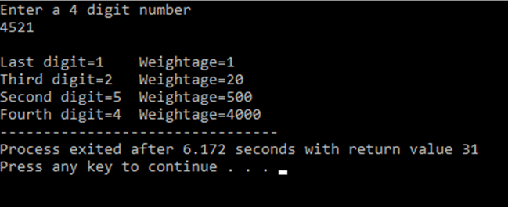

**EXPERIMENT 2.2:**

**Aim:** Write a program to find largest number and smallest number out of 2 numbers given as input. Use Conditional operator for this program.

**Program:**

*#include<stdio.h>*

*void main()*

*{*

*int a,b,c,d;*

*printf("Enter first number ");*

*scanf("%d",&a);*

*printf("Enter second number ");*

*scanf("%d",&b);*

*c=a>b?a:b;*

*d=a<b?a:b;*

*printf("Largest number is %d and smallest number is %d",c,d);*

*}*

**Input and Output:**

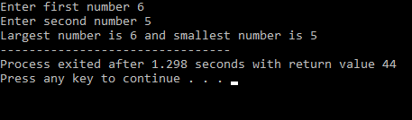

**EXPERIMENT 3.2:**

**Aim:** Write a program that accepts a character from keyboard and checks as follows:

- Whether the input character is a digit

- Whether the input character is a lower case letter

- Whether the input character is an upper case letter

- Whether the input character is a punctuation mark

- Whether the input character is a white space character

**Program:**

*#include<stdio.h>*

*void main()*

*{ char c;*

*printf("Enter something\n");*

*scanf("%c",&c);*

*if(c>= 'a' && c<='z')*

*printf("\nGiven input is an lower case Alphabet");*

*else if(c>='A' && c<='Z')*

*printf("\nGiven input is an upper case Alphabet");*

*else if(c>='0' && c<='9')*

*printf("\nGiven input is a Number");*

*else if(c==' ')*

*printf("\nGiven input is a white space character");*

*else*

*printf("\nGiven input is a symbol");*

*}*

**Input and Output:**

